There were one hundred and seventy-two students in the study. More juniors expressed interest in forensic psychology than any other group, with 8 students this year choosing this as their top interest area. The mean number of countries visited by students in sophomore was 4.86, the junior was 3.20, and seniors were 2.89. The pirate plot representing this data as follows;
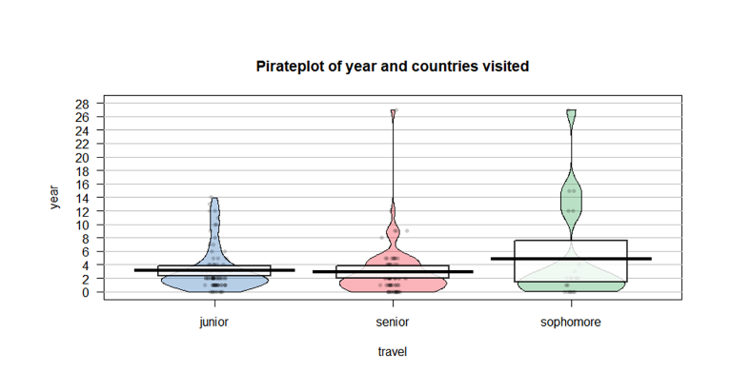

The pirate plot is a graphical representation of the raw data's distribution. It is a symbol of the vast nature of travel for the different countries visited by each student in the different years. A figurative indication that as a student go up through their college years, the more they are likely to visit other countries. The extreme values are for exceptions who have an opportunity of traveling widely. The pirate plot also represents descriptive statistics such as the mean, median, and mode from the area where the students are most concentrated. The interquartile range is defined by the rectangular figures which extrapolate the probability of data mean falling around that area. The mean (50%) in the dark middle line the upper quartile (75%) in the upper rectangular line while the lower quartile (25%) in the lower rectangular line. Further on, a scatter plot is needed to identify if there is a relationship between height and the number of countries visited. The scatter plot does not show any correlation between height and the number of countries visited. Even the correlation value of 0.14 and a margin error of 0 support that there is a very weak to almost no correlation. These results were acquired after accounting for the missing data through pairwise deletion ("use = "pairwise.complete.obs"), an excel function for deleting par values, and completing missing values.
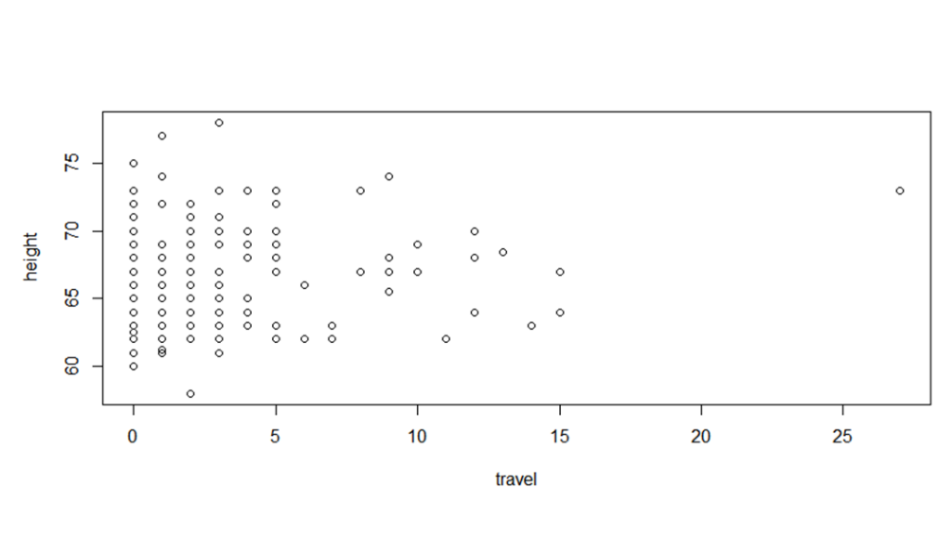
The internal consistency reliability of the conscientiousness scale is 0.82, which is within the acceptable level of reliability. The acceptability level is classified as being above 0.7 on the conscientiousness scale. The mean level of the conscientiousness scale for all members of the class is 3.69 within a margin of 0. The correlations between conscientiousness and neatness is 0.52 (moderate positive correlation), conscientiousness and number of countries visited is -0.20 (weak negative correlation), and neatness and number of countries visited is -0.05 (very weak negative correlation or no relationship). Conscientiousness and neatness are related hence influence each other positively, but conscientiousness and number of visits and neatness and number of visits are not related.

Table 1
Descriptive statistics
 |  |  | Correlations
 | M | SD | 1 | 2 | 3
Conscientiousness | 3.69 | 0.82 | 0.52
Neatness | 3.05 | 1.73 | 0.52 | -0.20
Number of countries visited | 3.27 | 0.95 | .20 | .05 | -0.05

